Bike Taxi Driver Job India: Salary, Kaise Join Karein aur Top Platforms
By Vahan · Updated: 27 June 2026 | Published: 27 June 2026
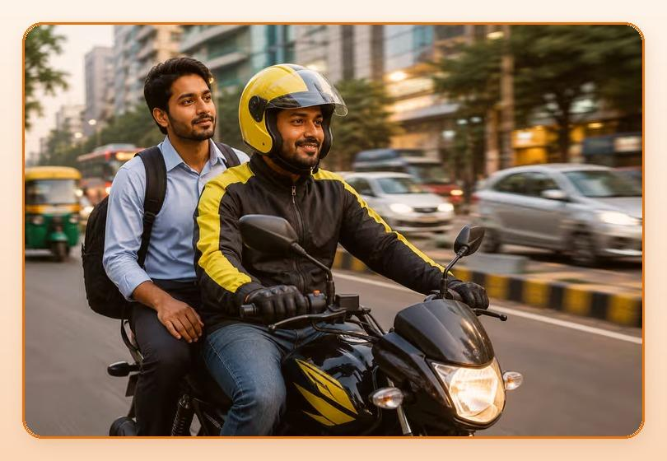
Summarize with ChatGPT · Gemini · Claude · Perplexity (tool icons in design)

Key Takeaways
- Rapido, Ola Bike, Uber Moto jaise platforms ne lakho riders ko ek aisa kaam diya hai jo flexible bhi hai aur profitable bhi.
- Koi fixed office nahi, koi boss nahi. Sirf aapki bike, aapka phone, aur aapki marzi.
- Ek active bike taxi driver jo 8-9 ghante kaam kare, wo easily Rs.700-Rs.1,000 per day earn kar sakta hai.
- Entry easy hai, earning decent hai, aur aap apne khud ke boss ho.

Table of Contents
- India Mein Bike Taxi Industry Kyon Boom Kar Rahi Hai?
- Bike Taxi Driver Salary India: Platform-Wise Kitna Milta Hai?
- Bike Taxi Driver Ke Liye Eligibility: Kya Chahiye?
- Rapido, Ola Bike ya Uber Moto: Kaun Sa Platform Join Karein?
- City-Wise Bike Taxi Earning: Apne Sheher Ka Data
- Bike Taxi Mein Zyada Kamaane Ke Smart Tips
- Real Story: Ek Bike Taxi Driver Ki Journey
- Bike Taxi Job Kaise Start Karein? Step-by-Step
- FAQs: Bike Taxi Job Ke Baare Mein Common Sawaal
- Conclusion: Kya Bike Taxi Job Aapke Liye Sahi Hai?

Aapke paas bike hai aur aap usse sirf commute ke liye use kar rahe hain? Toh aap ek badi opportunity miss kar rahe hain. Bike taxi industry India mein tezi se badh rahi hai. Rapido, Ola Bike, Uber Moto jaise platforms ne lakho riders ko ek aisa kaam diya hai jo flexible bhi hai aur profitable bhi. Koi fixed office nahi, koi boss nahi. Sirf aapki bike, aapka phone, aur aapki marzi.
Agar aap ek aisi job dhundh rahe hain jahan entry aasaan ho, income turant shuru ho, aur kaam ka time aap khud decide karein, to bike taxi driver job aapke liye ek solid option hai.

India Mein Bike Taxi Industry Kyon Boom Kar Rahi Hai?
India mein traffic ek bada problem hai, khaaskar metro cities mein. Car se zyada fast aur auto se zyada affordable, bike taxi exactly woh gap fill karta hai jo logon ko chahiye. Rapido akele har roz 20 lakh se zyada rides complete karta hai. Tier-2 aur Tier-3 cities mein bhi bike taxi ki demand tezi se badh rahi hai kyunki public transport limited hai.
Government ne bhi kai states mein bike taxi ko legal framework de diya hai. Matlab yeh industry ab sirf grow karegi. Jo aaj join karte hain, unhe kal better earning milegi.

Bike Taxi Driver Salary India: Platform-Wise Kitna Milta Hai?
Sabse pehla sawaal jo har koi poochta hai: bike taxi se kitna kama sakte hain? Yahan realistic figures hain:
Platform | Monthly Earning (Approx.) | Extra Bonuses
Rapido | Rs.15,000 - Rs.25,000 | Ride targets, surge bonuses
Ola Bike | Rs.12,000 - Rs.22,000 | Weekly performance bonus
Uber Moto | Rs.14,000 - Rs.24,000 | Festive season incentives
Multiple Platforms | Rs.25,000 - Rs.40,000+ | Variable

Morning office rush (8-10 AM) aur evening rush (6-9 PM) mein rides zyada milti hain. Ek active bike taxi driver jo 8-9 ghante kaam kare, wo easily Rs.700-Rs.1,000 per day earn kar sakta hai. Mahine ka hisaab lagao, aur figure impressive hai.

Bike Taxi Job Chahiye? Abhi Apply Karein.
Get Started

Bike Taxi Driver Ke Liye Eligibility: Kya Chahiye?
Bike taxi join karna bahut simple hai. In cheezoin ki zaroorat hogi:
- Age 18 saal ya usse zyada
- Valid driving licence (2-wheeler)
- Apni bike ya scooter (100cc ya usse zyada)
- Smartphone (koi bhi Android chalega)
- Aadhaar Card aur PAN Card
- Vehicle RC aur insurance
- Police verification certificate (kuch platforms ke liye)
Koi degree nahi chahiye, koi experience nahi chahiye. Agar aap city ki roads jaante hain aur bike achhi tarah chalate hain, aap ready hain.

Rapido, Ola Bike ya Uber Moto: Kaun Sa Platform Join Karein?
Teeno platforms mein se koi bhi join kar sakte ho. Lekin ek comparison helpful rahega:
Platform | Best For | Availability
Rapido | Metro aur Tier-2 cities, high ride volume | Most cities in India
Ola Bike | Ola ecosystem users, steady rides | Select cities
Uber Moto | Premium riders, higher per-ride rate | Metro cities mainly

Best strategy: ek se zyada platforms par register karo. Jab ek app par rides kam hon, doosra app backup karta hai. Isse monthly earning consistent rehti hai.

City-Wise Bike Taxi Earning: Apne Sheher Ka Data
City | Average Monthly Earnings
Delhi NCR | Rs.20,000 - Rs.32,000
Bangalore | Rs.22,000 - Rs.35,000
Mumbai | Rs.18,000 - Rs.30,000
Hyderabad / Pune | Rs.18,000 - Rs.28,000
Tier-2 Cities | Rs.12,000 - Rs.20,000

In figures mein surge pricing aur referral bonuses shamil nahi hain. Weekend aur rainy days mein surge pricing se earning 30-50% aur badh jaati hai.

Bike Taxi Mein Zyada Kamaane Ke Smart Tips
- Rush Hours Ko Target Karo: Subah 8-10 aur shaam 6-9 mein rides double ho jaati hain
- Multiple Apps Use Karo: Rapido aur Ola Bike dono chalao, income consistent rahegi
- Rating 4.5 Se Upar Rakho: High rating means priority ride allocation
- Referral Program Use Karo: Dosto ko refer karo aur extra Rs.500-Rs.2,000 earn karo
- Bike Maintain Karo: Clean aur well-maintained bike se ratings better milti hain
- Station aur Mall Ke Paas Raho: High demand zones mein rides jaldi milti hain

Real Story: Ek Bike Taxi Driver Ki Journey
"Main pehle ek factory mein kaam karta tha, Rs.10,000 per month. Ek dost ne Rapido ke baare mein bataya. Pahle mahine mein hi Rs.18,000 earn kiye. Ab do saal ho gaye hain, mahine ka Rs.28,000-30,000 hota hai. Aur sabse bada fayda, koi supervisor nahi, koi time nahi." (Suresh, 26, Bangalore)

Bike Taxi Job Kaise Start Karein? Step-by-Step
1. Vahan.co/jobs par jaao
2. Bike Taxi category select karo
3. Apna naam, phone number aur city enter karo
4. Documents upload karo (licence, RC, Aadhaar, PAN)
5. Background verification complete karo
6. 2-3 din mein account activate ho jaata hai, aur aap ready ho jaate ho!

FAQs: Bike Taxi Job Ke Baare Mein Common Sawaal
Q: Kya purani bike se bhi bike taxi join kar sakte hain?
Haan, lekin bike ka registration valid hona chahiye aur insurance up-to-date hona chahiye. Zyada platforms 2015 ke baad ki bikes accept karte hain.
Q: Rapido join karne ke liye kitna time lagta hai?
Typically 3-5 working days. Vahan.co se apply karne par process aur faster ho jaati hai.
Q: Kya bike taxi aur delivery job dono ek saath kar sakte hain?
Haan, kai riders dono karte hain. Subah bike taxi, evening delivery. Yeh maximum earning ka ek popular formula hai.
Q: Bike taxi mein accident hua toh kya hoga?
Major platforms basic accident insurance dete hain. Lekin apna ek alag personal accident cover lena hamesha smart decision hai.
Q: Kya bike taxi mein mahine ka fixed income hota hai?
Fixed nahi hota, lekin consistent kaam karo to income predictable ban jaati hai. Zyada ride karo, zyada earn karo.

Conclusion: Kya Bike Taxi Job Aapke Liye Sahi Hai?
Agar aapke paas bike hai aur aap extra income chahte hain, to bike taxi job India mein abhi ke liye ek excellent choice hai. Entry easy hai, earning decent hai, aur aap apne khud ke boss ho.
India mein bike taxi industry sirf badhne wali hai. Aaj join karo, aur is growth ka faida uthao. Vahan.co par free registration karo aur kal se earning shuru karo.
Abhi Apply Karo: vahan.co/jobs

Bike Taxi Job Chahiye? Abhi Apply Karein: vahan.co/jobs

